TRP’s Trauma-Informed Care E-Newsletter

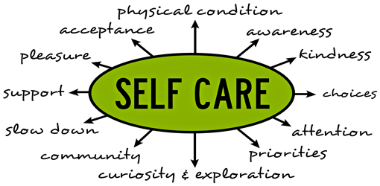

This newsletter is one of a two part in-depth series on self-care for those in helping professions (to follow up on the November 2017 edition that introduced the concept and its importance in creating a trauma-informed system of care, see below for a copy of this edition). This is part 1, in which we discuss how to participate in ongoing self-care techniques. During the next quarter we will provide part 2 in which we discuss how to participate in self-care after experiencing a trauma.

“Trauma exposure response,” “compassion fatigue,” and “secondary traumatic stress” can be categorized into the term “trauma stewardship.” Trauma *stewardship* reminds us that as clinicians we are entrusted with people’s stories, honored to create a space for them to experience their suffering, and privileged to participate in a role of being called to help. To be successful in our roles, we must make trauma stewardship a daily practice. In this newsletter, we provide ways in which you can tend to and guide people who are suffering, while avoiding the tendency to internalize peoples’ struggles and experience a trauma exposure response.

Experiencing a trauma exposure response is not limited to individuals working with traumatized clients. These responses can occur in many professions, a few including: veterinarians, ecologists, doctors, biologists, and therapists. Trauma exposure response symptoms may present as: feeling helpless and hopeless, feeling like you can never do enough, hypervigilance, diminished creativity, chronic exhaustion, physical ailments, and guilt. To prevent or combat these symptoms, first, we need to be aware of the stress from our work and how it’s individually impacting us. To do this, **the most important self-care practice to engage in is coming into the present moment.** We are unable to evaluate what we need unless we first become aware of our current state.

For this newsletter, we want to invite you to become deeply aware of the effects your work has on you, both negative and positive. We ask that you set aside 20 minutes of your workday to sit alone and ponder over the following questions and engage in the following tasks:

* **How does your work affect you?**
* **How is your work benefiting you and those you serve?**
* **Before starting your workday, take a moment to literally stop in your tracks and ask yourself, “Why am I doing what I’m doing?” After you hear your answer, remind yourself, gently, that you are making a choice to do this work. Take a deep breath; breathe in both the responsibility and the freedom in this acknowledgment.**
* **Every single day, think of one person you are grateful to and tell that person so. You can start with those close to you and slowly branch out to expressing your gratitude for all the “teachers” in your life.**
* **Regularly consult with someone about why you are doing what you are doing. Choose a trustworthy, supportive, wise person. Ask this person to listen attentively and provide you with feedback. It is critical to not be isolated in our work.**
* **Initiate a co-counseling type of relationship with a colleague or friend whom you can call on regularly. Agree to counsel each other, if only for five minutes. Let your friend start the talking and listen attentively with a calming presence. Then it’s your turn. Say whatever is in your heart and mind, moving it out of your system, while your partner in the exercise listens attentively for five minutes. Repeat frequently.**

Other resources:

* This newsletter was strongly informed by the book, *Trauma Stewardship* by Laura van Dernoot Lipsky and Connie Burk. This book assists individuals who care for others in their ability to care for themselves.
* For free, confidential, 24/7 support, resources, and information for every aspect of your life, contact Work-Life Solutions at (844)-365-4587. Highly trained clinicians are available to offer resources and confidential emotional support.
* Visit calm.com for guided meditation.
* Visit <https://hr.wustl.edu/focus-on-your-personal-wellness/> to learn about resources that will help you track and manage your health.
* Visit <https://hr.wustl.edu/develop-and-learn/> for resources on self-development, career development, and leadership opportunities.
* Visit <https://hr.wustl.edu/engage/> for information on engaging with colleagues, the University, and the community.